**Experiment Title – 2.4**

**Student Name:** YANA SRIVASTAVA **UID:** 20BCS2279

**Branch:** BE-CSE **Section/Group:** 20BCS-WM-906/B

**Semester:** 5th  **Date of Performance:** 06/10/2022

**Subject Name:** PBLJ LAB **Subject Code:** 21 CSP-321

**1. Aim/Overview of the practical:** Employee Management System

Create a menu based Java application with the following options.

1. Add an Employee

2. Display All

3. Exit

If option 1 is selected, the application should gather details of the employee like

employee name, employee id, designation and salary and store it in a file.

If option 2 is selected, the application should display all the employee details.

If option 3 is selected the application should exit.

**2. Software/Hardware Requirements:** IntelliJ

**3. Algorithm/pseudo code:**

Step1: Start execution.

Step2: Declare 4 ArrayList to store employee name, empoyee id, designation and salary.

Step3: Using the constructor add values to the arraylist.

Step4: Make a display function to Display the contents of each arraylist using a for loop.

Step5: In main function take choices as input inside a switch statement.

Step6: Call the relevant functions as per the entered choices.

Step7: Stop execution.

**4. Steps for experiment/practical/Code:**

package com.chirag;

import java.io.*;

import java.util.*;

class exp2_4 {

public static void main(String[] args) {

Scanner input = new Scanner(System.in);

int choice;

String name, designation;

int id, salary;

FileWriter fileWriter = null;

BufferedWriter bufferedWriter = null;

FileReader fileReader = null;

BufferedReader bufferedReader = null;

do {

System.out.println("1. Add an Employee");

System.out.println("2. Display All");

System.out.println("3. Exit");

System.out.println("ENTER YOUR CHOICE : ");

choice = input.nextInt();

switch (choice) {

case 1:

try {

fileWriter = new FileWriter("employee.txt",

true);

bufferedWriter = new BufferedWriter(fileWriter);

System.out.println("ENTER NAME : ");

name = input.next();

System.out.println("ENTER ID : ");

id = input.nextInt();

System.out.println("ENTER DESIGNATION : ");

designation = input.next();

System.out.println("ENTER SALARY : ");

salary = input.nextInt();

bufferedWriter.write(name + " " + id + " " +

designation + " " + salary);

bufferedWriter.newLine();

bufferedWriter.close();

} catch (IOException e) {

System.out.println("ERROR OCCURED");

}

break;

case 2:

try {

fileReader = new FileReader("employee.txt");

bufferedReader = new BufferedReader(fileReader);

String line;

while ((line = bufferedReader.readLine()) != null) {

System.out.println(line);

}

bufferedReader.close();

} catch (IOException e) {

System.out.println("ERROR OCCURED");

}

break;

case 3:

System.out.println("EXITING");

break;

default:

System.out.println("INVALID CHOICE");

}

} while (choice != 3);

}

}

**5. Result/Output/Writing Summary:**

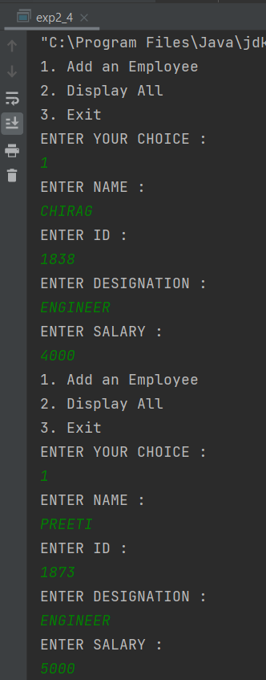

***SCREENSHOT - 1***

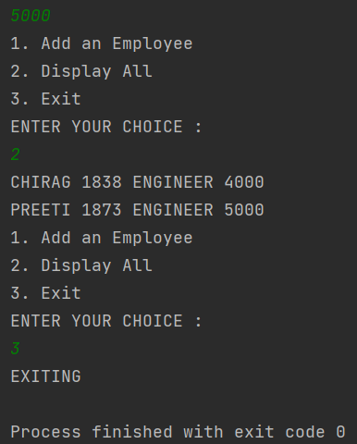

***SCREENSHOT - 2***

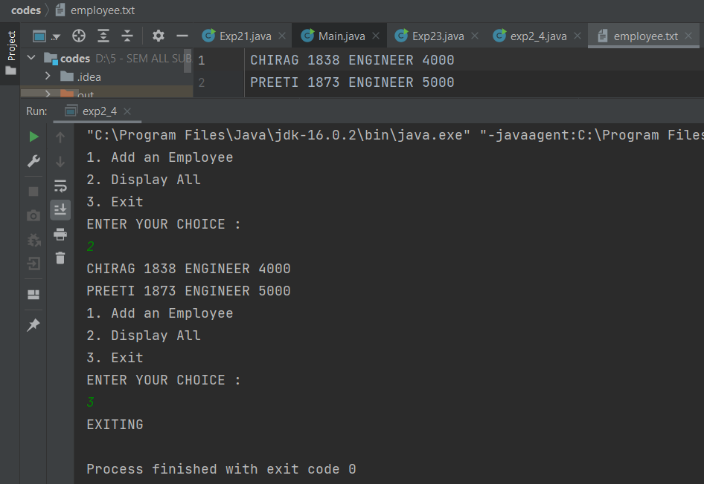

***SCREENSHOT - 3***

**Learning outcomes (What I have learnt):**

1. **Learned about ArrayList.**
2. **Learned about Switch Statement.**
3. **Learned about ArrayList Travesal.**
4. **Learned how to store entries directly to txt file.**